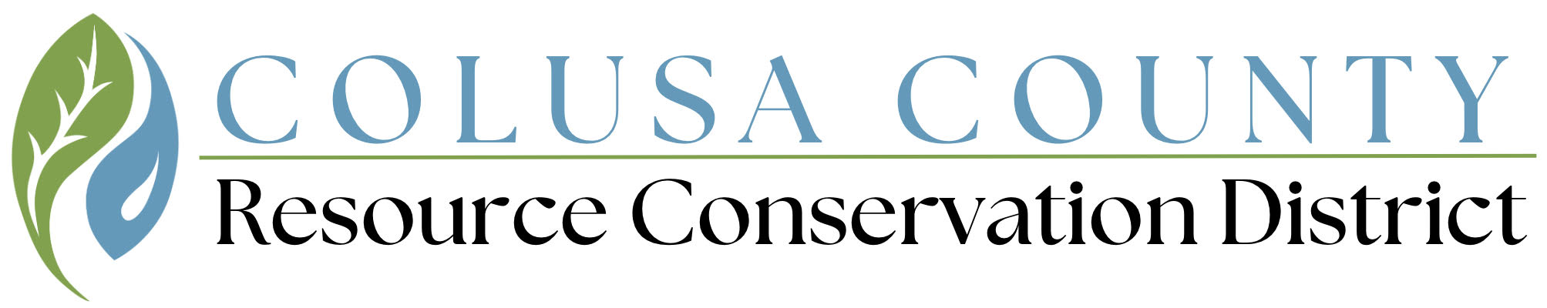

**Regular Meeting of the Board**

**Colusa County Resource Conservation District**

**Agenda**

**When:**  **Tuesday, July 16th, 2024**

**Where:**  **Colusa County Natural Resource Conservation Service Office**

**100 Sunrise Blvd. Suite B, Colusa, CA. 95932**

**Time:**  **3:00- 5:00PM**

**Please note:**

**PUBLIC COMMENT**- Any member of the public may address the Board concerning any matter on the agenda before or during its consideration of the matter. Public comment is limited to three (3) minutes per person and no more than fifteen (15) minutes per topic. For good cause, the Board Chairman may waive these limitations.

**AGENDA ITEM TIME FRAME**- All time allotments are suggested by staff and are an estimate only and subject to change.

**ACCESSIBILITY**- If you have a disability and require a reasonable accommodation to fully participate in this event, please contact CCRCD Staff before the day of the meeting via email (insert preferred email here) or telephone (530)473-9346 to discuss your accessibility needs.

**OPENING/CALL TO ORDER**

**PUBLIC COMMENT FROM THE FLOOR (Non-Agenda Items)**

**CONSENT CALENDAR: (5 minutes)**

**Approve Consent Agenda Item A and B**

*Any board member may request and remove any item from the consent agenda and place that item on the regular portion of the agenda as specified.*

1. **Agenda-** July 16th, 2024
2. **Minutes-** June 18th, 2024

**FINANCIAL REPORT: (10 minutes)**

1. **Fund Balance-** July 2024
2. **Claims-** July 2024 Review and Sign

**REPORTS: (15 minutes)**

1. **Natural Resource Conservation Service (NRCS) Report**
2. **Colusa County Agricultural Commissioner’s Report**
3. **Colusa County Board of Supervisor’s Report**
4. **CCRCD Board Member Reports**

**GENERAL BUSINESS ACTION ITEMS:**

1. **Personnel Committee Report: Discussion and Approval of Personnel Promotions and Raises**
2. **Ratify Request for Proposals for Forest Health 2021**
3. **Discussion and Approval of Forest Health Biomass Utilization Amendment to Existing Contract**
4. **Review and Approve Request for Statement of Qualifications and Bid Proposal to Registered Professional Forester and other Consultants**
5. **Purchase of Truck and Water Trailer**
6. **2024 Local Agency Biennial Notice**

**INFORMATIONAL/DISCUSSION ITEMS: (10 MINUTES)**

1. ***Director Requirements:*****Ethics and Anti-Harassment Meeting**
2. **CCRCD Staff Reports and Project Updates**
3. **Director and Staff Training**

**IDENTIFICATION OF ITEMS FOR FUTURE MEETINGS:** *Board members may request items to be placed on future agendas.*

**ADJOURNMENT: August 20th, 2024 @ 3pm, Colusa Industrial Properties Conference Room, 100 Sunrise Blvd., Colusa, CA 95932**